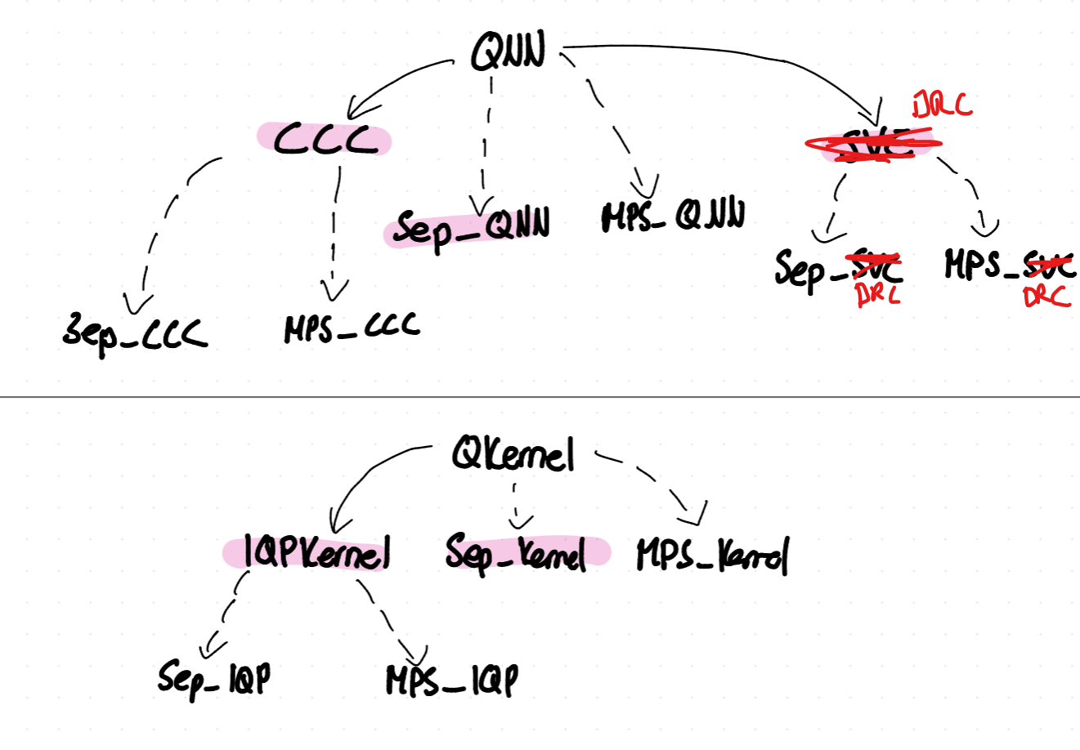
Existing:
CCC
normalized and padded
Encoding:amplitud embedded with n_input_copies
Ansatz: PennyLane’s StronglyEntanglingLayers
Measurement: expectation value of Z on the first qubit.
Training: square loss,
Tuned hyperparameters:
• learning_rate ∈ {0.001, 0.01, 0.1} (step size of optimizer)
• n_layers ∈ {1, 5, 10} (how many times ansatz)
• n_input_copies ∈ {1, 2, 3} (how many copies of the encoded input state ∣ψx⟩ you prepare before the ansatz)
DRC (DataReuploadingClassifier)
normalized and padded to a multiple of 3 features
Encoding:
- Split $x∈R^{d}$into blocks of 3 features.
- Each block $x^{\left(j\right)}$is sent to one qubit.
- On each qubit and each layer $l$, apply a single–qubit rotation
$U(x^{\left(j\right)}∘ω^{\left(j , l\right)}+θ^{\left(j , l\right)})$, implemented as RotZ – RotY – RotZ with trainable vectors $ω^{\left(j , l\right)},θ^{\left(j , l\right)}$.
Ansatz:
- After each per-qubit embedding block, apply a CZ “ladder” entangling neighbouring qubits.
- Repeat the pattern [embed all qubits] + [CZ ladder] for $n_{\text{layers}}$reuploading layers.
Measurement:
- For a chosen set of output qubits (size $n_{\text{max}}$), compute fidelities $F_{j}^{0}(x)$, $F_{j}^{1}(x)$to $∣0⟩$and $∣1⟩$(probabilities of measuring 0 or 1).
- Prediction uses the average fidelity to $∣0⟩$or $∣1⟩$over these qubits.
Training:
- Weighted square loss on the fidelities (Eq. C3 in the paper), with additional trainable weights $α_{j}^{0},α_{j}^{1}$.
Tuned hyperparameters:
- learning_rate ∈ {0.001, 0.01, 0.1} (step size of optimizer)
- n_layers (reuploading layers) ∈ {1, 5, 10, 15}
- observable_type ∈ {single, half, full} (how many output qubits are used in the loss and prediction)
IQPKernel (IQPKernelClassifier)
Preprocessing:
- Same feature normalisation as for the other models.
Encoding / feature map:
- PennyLane’s IQPEmbedding with a given number of repeats.
- IQP-style circuit: Hadamards followed by data-dependent diagonal Z and ZZ phase gates, repeated repeats times.
Ansatz:No vqc, kernel
Kernel definition:
- For a pair (x, z), prepare the embedded state for z, apply the inverse embedding of x, and measure all qubits.
- The probability of outcome $∣0…0⟩$gives the kernel value
$K_{\text{IQP}}(x,z)=∣⟨ψ(x)∣ψ(z)⟩∣^{2}$.
Training:
- Classical SVM (scikit-learn SVC) with this precomputed quantum kernel matrix.
Tuned hyperparameters:
- repeats (IQPEmbedding layers) ∈ {1, 5, 10}
- C (SVM regularization) ∈ {0.1, 1, 10, 100}
SVC (SeparableVariationalClassifier)
Normalized input features.
Encoding:
- One qubit per feature.
- Data encoding $V(θ,x)$consists of L layers; each layer on every qubit applies:
  - a trainable single–qubit rotation Rot(θ);
  - a product angle embedding RY(x_j) on qubit j.
- After the L encoding layers, there is one additional layer of trainable single–qubit Rot gates.
Ansatz:
- Only single–qubit gates; no entangling gates anywhere.
- The full circuit is a tensor product of 1–qubit circuits (fully separable).
Measurement / output:
- Observable $O=\frac{1}{n}\sum_{j=1}^{n}{Z_{j}}$(average of Z over all qubits).
- Raw score: $f(θ,x)=⟨O⟩∈[-1,1]$.
- Probability of class +1: $P(+1∣θ,x)=σ(6f(θ,x))$with the logistic sigmoid $σ$.
Training:
- Binary cross-entropy loss using these probabilities.
Tuned hyperparameters:
- learning_rate ∈ {0.001, 0.01, 0.1}
- encoding_layers L ∈ {1, 3, 5, 10}
Sep_Kernel (Separable Kernel Classifier)
Preprocessing:
- Same scaling / normalisation as for SVC and IQPKernel.
Encoding / feature map:
- Fully separable angle embedding, similar in spirit to SVC’s encoding:
  - On each qubit j and each layer ℓ, apply only single–qubit rotations (trainable Rot gates and data-dependent RY(x_j)).
  - No entangling gates at any depth.
- This defines a product-state feature map
$∣ψ_{\text{sep}}(x)⟩=⨂_{j}∣ψ_{j}(x)⟩$.
Kernel definition:
- kernel is the squared overlap of these product states:
$K_{\text{sep}}(x,z)=∣⟨ψ_{\text{sep}}(x)∣ψ_{\text{sep}}(z)⟩∣^{2}$.
- Because the state factorises, the kernel factorises as a product of 1–qubit overlaps
$K_{\text{sep}}(x,z)=\prod_{j}{κ_{j}}(x,z)$and is efficiently computable classically.
Ansatz:
- No trainable quantum ansatz beyond the fixed separable feature map.
- All learning happens in the classical kernel method.
Training:
- Classical SVM (SVC) with this separable quantum-inspired kernel matrix.
Tuned hyperparameters:
- encoding_layers L (depth of separable feature map) ∈ {1, 3, 5, 10}
- C (SVM regularization) ∈ {0.1, 1, 10, 100}
In short:
CCC: VQC with amplitude encoding of several copies, with entangling ansatz composed of many stronglyentanglinglayers, then measure on first qubit.
DRC: VQC feeding data at each layer, split into blocks (qubit per block) of 3 feautures. Each qubit getrs trainable single qubit rotation, whose angles are linear functions of its 3 features, then a CZ ladder entangles neighbor qubits. At the end, compute likelyhood of $∣0⟩$,or $∣1⟩$, and train them to match y.
SVC: non entangling VQC, every qbit models a feauture. Do L times, Rot then ry depending on data xj. Measure Z on all, average, pass through sigmoid, and train with binary cross entropy.
IQPKernel: that uses IQPEmbedding (Hadamards, data dependent diagonal phases, including ZZ terms) circuit to map each input $x$ to a quantum state $∣ψ(x)⟩$. Then estimate the overlap, the kernel, for each pair of point. Train standard SVM on this.
SepKernel: non entangling kernel, similar to svc, product of 1qubit angle embedding circuits. The kernel is squared overlap which factorises into a product of 1-qubit overlaps. Then as normal SVM.
New Models:
CCC-A: CCC with entanglers removed but keep amplitude encoding (entangled).
CCC-B: CCC but replace amplitude encoding with product angle encoding and only single-qubit Rot.
DRC-A: DRC minus CZ.
DRC-B: “DRC as Reuploading SVC” (per-qubit reuploading, only 1-qubit gates).
Separable IQPKernelClassifier

CCC with entanglers removed from the variational circuit, but keeping amplitude
Encoding, isolate the effect of entanglement in the trainable part,
though encoding may still be entangled and not efficiently simulable for large n.
CCC fully separable
Start from CCC but replace amplitude encoding by product angle encoding and
use only single-qubit Rot gates.
then: Structurally inspired by CCC, but made fully separable (no
entangling gates in encoding or ansatz), SVC in CCC way.

DRC minus CZ” (same blocks, no entanglers), closest structure wise
Reuploading SVC (one feature per qubit, Rot–RY(w x + b) repeated, average Z).
Separable IQPKernelClassifier: product-state feature map obtained by removing all multi-qubit diagonal interactions from the original IQP circuit and retaining only single-qubit Z rotations. Kernel now decomposable into a product of single-qubit overlaps

MPS
MPS_CCC
MPS_DRC
MPS_Kernel

